Exploring Cybersecurity Basics

Part 1: Understanding the CIA Triad

Step 1: Learn the CIA Triad
The CIA Triad represents three key principles of cybersecurity:
1. Confidentiality: Protecting information from unauthorised access.
2. Integrity: Ensuring information is accurate and unaltered.
3. Availability: Ensuring information and systems are accessible when needed.

Activity: Applying the CIA Triad

Scenario: A university’s student records database contains sensitive information like grades, contact details, & IDs.
1. For each principle, describe how it applies to the database, and one technique for employing each principle:
• Confidentiality:
• Integrity:
• Availability:

Discussion Prompt
• What would happen if one of these principles is compromised?

Part 2: Identifying and Mitigating Cybersecurity Threats

Step 1: Learn About Common Threats
• Phishing: Fake emails tricking users into revealing information.
• Malware: Harmful software like viruses or ransomware.
• Social Engineering: Manipulating people to gain unauthorised access.

Activity: Spot the Phish
Examine the phishing email.

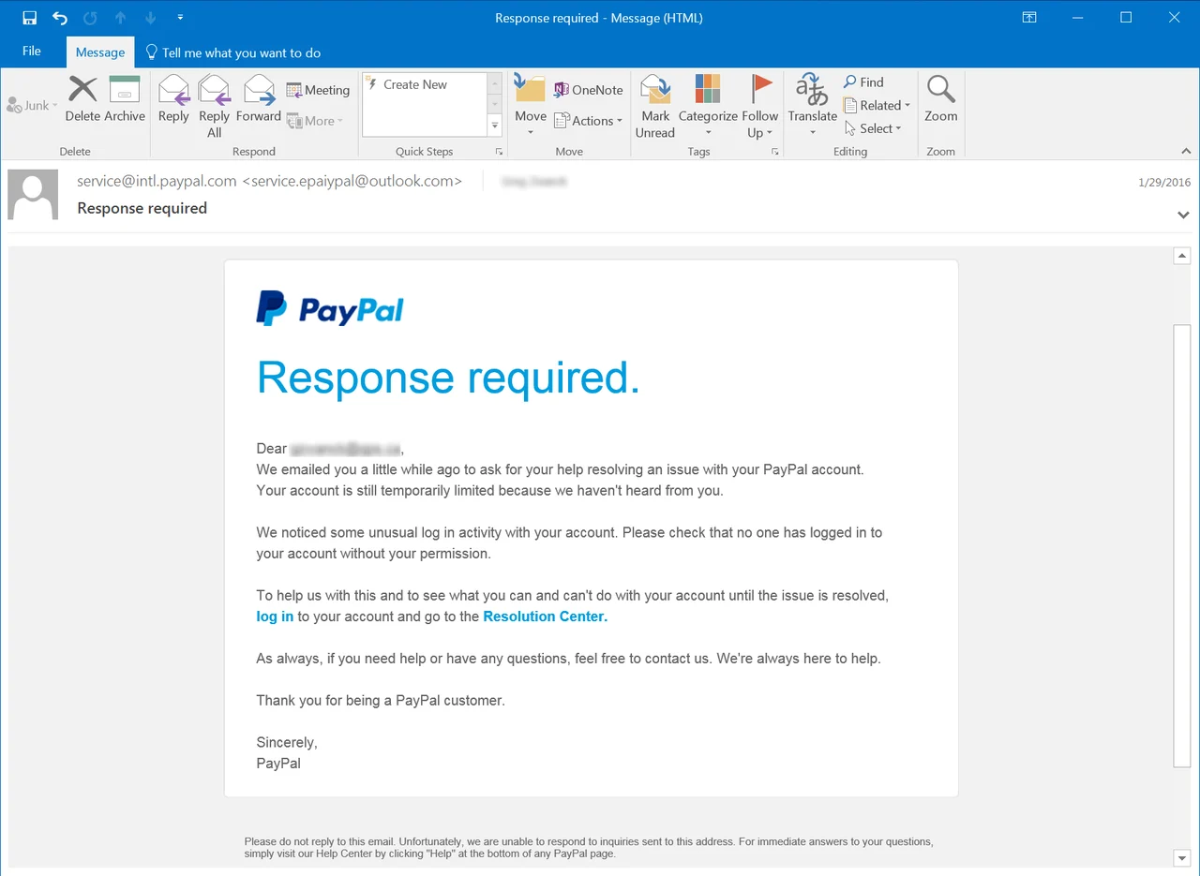

Task: Identify the red flags in the phishing email:

Activity: Malware Mitigation
Read the following scenario:
“You receive a pop-up on your computer claiming your system is infected and you must download software to fix it.”

Task: What steps should you take to mitigate this threat?

Activity: Social Engineering
- What percentage of cyber attacks come from social engineering? Use the internet and add a source

- Search for different types of social engineering attacks and choose one that you find interesting. Write a short paragraph that explains the attack, and how to best prevent it.

Part 3: Observing Basic Security Practices

Step 1: Passwords and Security

Activity: Password Strength Testing
1. Create a sample password following these guidelines:
• At least 12 characters.
• Mix of upper and lowercase letters, numbers, and symbols.
2. Test the strength of your password using How Secure Is My Password.

Password:

Estimated time to crack your password:

3. Now try and play around with different combinations of passwords (e.g., a long passphrase of just text)

Reflection: What did you learn about creating strong passwords?

Step 2: Account Breaches

Activity: Investigating Breach Alerts
1. Use the tool Have I Been Pwned to check if your email address has been involved in a data breach.
2. Answer the following questions:
• Was the email found in any breaches?
• If it were to be found, what steps should you take to secure the account?

Step 3: Protecting Individuals (Research Question)

Activity: Setting up a personal computer
For this activity, please look at Part 2 of Project 2 “Building and Securing a Personal Computer System” in the Project 2 tile on Campus Online

